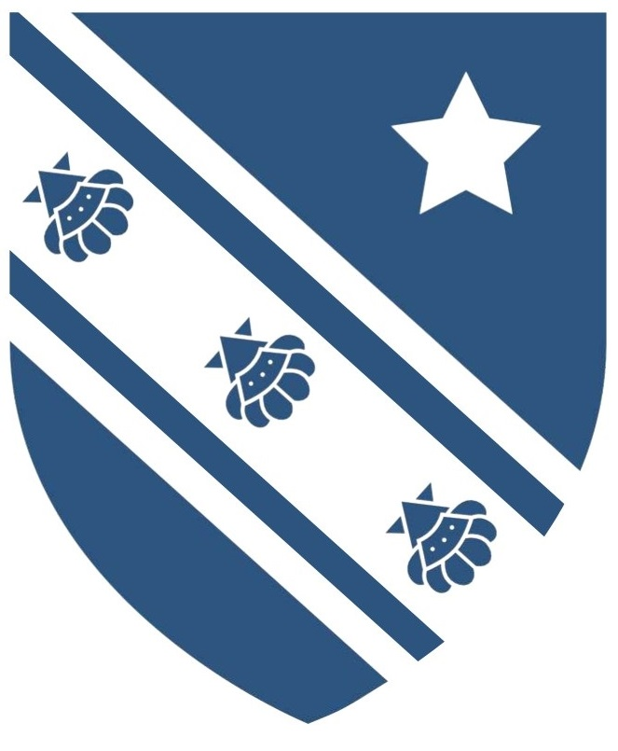 | Charles Darwin School  Social, Moral, Spiritual and Cultural Policy

Persons Responsible:
Governors: Ethos
SLT: Louise Rees
Written by: Rob Jones

Formally approved by the Curriculum Committee on: 23 June 2014
Reviewed and readopted: 29 June 2015
Reviewed and readopted: 18 June 2018
Next review date: June 2021

Table of Contents

1. Overarching principles of Social, Moral, Spiritual and Cultural [SMSC] development. 3
2. Background information 3
3. Spiritual aspects of personal development are evidenced by learners’: 3
4. Moral aspects of personal development are evidenced by learners’: 4
5. Social aspects of personal development are evidenced by learners’: 4
6. Cultural aspects of personal development are evidenced by learners’: 4
7. Examples of how this might be implemented 4
8. Promoting British Values 5
9. Democracy 6
10. The Rule of Law 6
11. Individual Liberty 6
12. Respect and Tolerance 6
13. Monitoring and implementation of the policy 7

- Overarching principles of Social, Moral, Spiritual and Cultural [SMSC] development.
  - All members of staff are responsible for teaching and learning that encourages participation, creativity, reflection and independence; assessment and feedback that values students’ work and effort; and activities that develop teamwork, leadership skills and self-reliance.
  - Opportunities are created by the school for pupils to take part in a range of social, artistic, cultural, sporting, dramatic, musical, mathematical, scientific, technological events and activities that promote aspects of pupils’ SMSC development
- Background information
  - Social Moral, Spiritual and Cultural development takes place throughout the life of a pupil at Charles Darwin School. It is important that all students leave the school not only with a set of qualifications that will give firm foundations to the start of a career, but the tools to understand the world and communicate effectively and responsibly with the people within it. This development of tolerant, caring, resilient and world-aware young people is influenced throughout the academic curriculum in lessons, supported by the pastoral system; through year teams and tutor time and through extra-curricular activities and experiences. Each subject area and year group are responsible for providing the support and guidance to develop children into young adults who are capable of understanding the world around them as they define their own path beyond Charles Darwin School.
  - Pupils should be encouraged to be developing their thinking around the four themes of SMSC:
- Social: How should I interact with other people?
- Moral: What sort of person do I want to become?
- Spiritual: Who am I? Where do I fit in? Why am I here?
- Cultural: Where do I belong? What is my identity?
  - A detailed breakdown of each of the four themes of SMSC taken from the OfSTED (2012) framework demonstrate the areas in which pupils at Charles Darwin could expect to experience enrichment:
- Spiritual aspects of personal development are evidenced by learners’:
  - Beliefs, religious or otherwise, which inform their perspective on life and their interest in and respect for different people’s feelings and values
  - Sense of enjoyment and fascination in learning about themselves, others and the world around them, including the intangible, the abstract and the unproven.
  - Use of imagination and creativity in their learning, discussion and socialising
  - Willingness to reflect on their experiences and share this with others, respecting others’ views and beliefs.

- Moral aspects of personal development are evidenced by learners’:
  - Ability to recognise the difference between right and wrong and their readiness to apply this understanding in their own lives and situations
  - Understanding of the consequences of their actions both in school and in the home and community
  - Ability to empathise with other viewpoints, where context might make obvious choices difficult.
- Social aspects of personal development are evidenced by learners’:
  - Use of a range of social skills in different contexts.
  - Understanding differences in social aspects of different religious, ethnic, sexual and socio-economic groups
  - Willingness to participate in a variety of social settings, cooperating well with others and being able to resolve conflicts effectively
  - Interest in, and understanding of, the way communities and societies function at different levels.
- Cultural aspects of personal development are evidenced by learners’:
  - Understanding and appreciation of the wide range of cultural influences that have shaped their own heritage, both locally, nationally and internationally.
  - Willingness to participate in, and respond to and share, for example, artistic, musical, sporting, mathematical, technological, scientific and cultural opportunities
  - Interest in exploring, understanding of, and respect for cultural diversity and the extent to which they understand, accept, respect and celebrate diversity, as shown by their attitudes towards different religious, ethnic and socio-economic groups in the local, national and global communities
- Examples of how this might be implemented
  - Examples of how this might be implemented in class, in tutor times and assembly and in extra-curricular activities include:
    - Students take part in a range of activities to develop their social skills
    - Students develop and apply understanding of right and wrong in lessons, tutor time and around the school
    - Students self-manage their feelings and respect the feelings and beliefs of others
    - Classroom display clearly promotes the values of SMSC
    - Students demonstrate a developing awareness and respect in relation to gender, sexuality, disability, race, religion, belief and culture
    - Students are encouraged to read and develop literacy skills to allow access to materials in books and on the Internet so that they can make informed judgements on their own learning journey
    - Students learn to participate in democratic processes to forge an understanding in how to behave and act in a socially and morally positive manner in modern Britain.
    - Students should be encouraged to develop a curiosity in artistic, sporting, political and other cultural events to broaden their understanding of different views and cultures.
    - Teachers use social, artistic and cultural references to promote SMSC
    - Teachers use positive role models to exemplify SMSC
    - Where issues arise, teachers skilfully question students to develop understanding and awareness of difficult issues so that students can discuss and debate in a safe environment.
    - Teachers use assemblies and collective situations to promote equality, diversity, reflection, dealing with adversity and conflict, aspiration and share and promote cultural experiences.
    - Teachers use tutor time activities to promote cultural, social and moral situations allowing pupil exploration of issues that affect young people and provide materials and situations to allow personal exploration. For example, healthy relationships and what these might look like.
    - Teachers use trips and visits to provide experiences that promote social, cultural and spiritual understanding of the wider world.
    - Extra-curricular activities, clubs and visits promote the positive values of SMSC and allow pupils to increase understanding of culture and diversity.
    - Students are given opportunities for leadership, through sports leaders, prefects, head boy and girl elections, school council and student voice.
- Promoting British Values
  - At Charles Darwin School we are all proud to belong to a community which encompasses both urban and rural catchments. Our work on experiencing social, moral, spiritual and cultural understanding empowers us to develop our students’ understanding and experience of modern British values: what it means to be a British citizen and how we can all promote tolerance, resilience and an understanding of other cultures. Not only are these values of British citizens, but underpin the values of good citizens in our global community.
Through the curriculum, through pastoral experiences during tutor times and assemblies and through extra-curricular work, our pupils gain an understanding of these values through:
    - Understanding of how citizens can influence decision-making through the democratic process;
    - Appreciating that living under the rule of law protects individual citizens and is essential for their wellbeing and safety;
    - Understanding that there is a separation of power between the executive and the judiciary, and that while some public bodies such as the police and the army can be held to account through Parliament, others such as the courts maintain independence;
    - Understanding that the freedom to choose and hold other faiths and beliefs is protected in law;
    - Accepting that other people having different faiths or beliefs to oneself (or having none) should be accepted and tolerated, and should not be the cause of prejudicial or discriminatory behaviour; and
    - Understanding the importance of identifying and combating discrimination.
- Democracy
  - Pupils are taught about democracy from a theoretical perspective in History and Citizenship which will be continued with the teaching of Philosophy and Ethics. These areas of humanities are where they consider the advantages and disadvantages of democracy, and how democracy and the law works in Britain, in contrast to other forms of government in other countries. Pupils also experience how democracy works by actively promoting democratic processes through the election of the head boy and head girl, which involve all pupils, teaching and non-teaching staff, from the hustings and selection through to manifesto and ballot box voting. Pupils also elect on a termly basis the student voice representatives who are then also shortlisted to run for school council. Student council and student voice both have decision making meetings that are minuted.
- The Rule of Law
  - Students are taught the value and reasons behind the rules which we abide by in school and also the wider laws that exist within society. Laws are covered in the history curriculum. The Police present in assembly on the law and we have representatives from Transport for London to assemblies with years 7-9 to discuss the law and the rules of using public transport. E-safety and the law is covered in all year groups via assemblies, the tutor programme and the Year 8 IT curriculum.
- Individual Liberty
  - Pupils are taught that with rights come responsibilities. We provide a curriculum that promotes debates and discussions within class. This enables learners to make informed choices based on the evaluation of facts. For example, students are taught about the risks of using the internet and how they can keep themselves safe in ICT lessons. Rights and ethics surrounding scientific discoveries, stem cells and designer babies are taught in science, as well as the importance of healthy personal and sexual relationships in drama (year 8 curriculum) and science (year 10 relationships curriculum). The curriculum in English explores individual liberty, rights and relationships throughout years 7-11.
- Respect and Tolerance
  - Respect and tolerance are promoted in all subject areas and through the pastoral system. Assemblies focus on developing an understanding that different cultures might have different values and beliefs and to use appropriate opportunities in lessons and through the pastoral programme to allow pupils to experience other cultures. Parents speak highly of the way in which that the school fosters the development of pupils’ understanding of respect and tolerance.
- Monitoring and implementation of the policy
  - Provision for SMSC is monitored and reviewed by the senior leadership team through presentation and regular feedback at SLT meetings
  - Regular audit of SMSC provision is conducted across the curriculum and through the pastoral programme.
  - SMSC is discussed and events planned at Faculty Workshop and Year team meetings.
  - Staff to share good practice
  - The provision of SMSC is the responsibility of all staff at Charles Darwin School.
June 2018

