CDS - WotW Key Vocabulary and Terminology

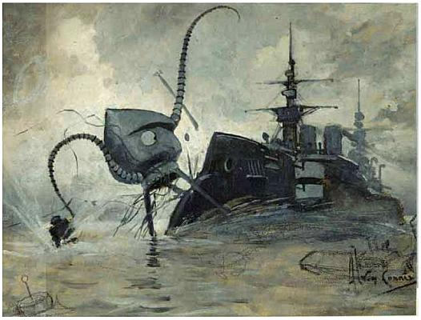

Vocabulary | Terminology
Apathetic  Arrogant  Articulate  Astute  Chivalrous  Conceited  Deranged  Discerning  Dismissive  Dispassionate  Empathy/Empathic  Faint-hearted  Feeble-minded  Hubris (hubristic)  Ineffectual  Infantalise  Inhumane  Intimidate  Jubilant  Monotonous  Passive  Patriarchal  Penitent  Pompous  Pragmatic  Prophet  Quixotic  Rational  Superficial  Unconventional  Vapid  Volatile  Vulnerable | Antagonist  Chronology  Climax  Cyclical  Denouement  Dialogue  Dynamic Character  Dystopia  Elegy/Elegiac  Epiphany  Exposition  Falling Action  Foreshadowing  Imperative  Juxtaposition  Linear plot  Metaphor  Motivation  Peripeteia  Protagonist  Rising Action  Simile  Static Character  Symbolic  Theme  Victim

